## UNIVERSITY COLLEGE OF ENGINEERING ARNI

**(A Constituent College of Anna University Chennai) THATCHUR , ARNI - 632301**



## A PROJECT REPORT

CREATING AN SPONSORED POST FOR INSTAGRAM

(ELECTRONICS AND COMMUNICATION ENGINEERING)

Faculty Mentor(s) Name

Mr. VENKATNARAYANAN .,M.E.,

By

**Sabari V**

Dhivya K

Harish A

Janarthan V

ANNA UNIVERSITY : CHENNAI 600 025



## BONAFIDE CERTIFICATE

Certified that this project report “**CREATING AN SPONSORED POST FOR INSTAGRAM”** is the bonafide work

who carried out the project work under my supervision.

## SIGNATURE SIGNATURE

Mrs.R.Ezhilarasi.,M.E.,(Ph.D.) Mr.Venkatnarayanan,M.E., HEAD OF THE DEPARTMENT SUPERVISOR

Department of ECE Department of ECE

University College of University College of

Engineering-Arni Engineering -Arni

Submitted for the project viva voce held on …………….

**INTERNAL EXAMINER EXTERNAL EXAMINER**

# ACKNOWLEDGEMENT

At the outset we express our deep gratitude to the almighty Lord for bestowing his grace and blessing upon us to complete the project. We convey our special gratitude and thank to our honourable Dean

**Dr .G. SENTHIL KUMAR,M.Sc.,M.phil.,Ph.D.,** for providing us with necessary facilities for the completion of our project and helping us with his valuable inputs.

We truly thank our project coordinator **Dr.R.EZHILARASI,M.E.,Ph.D.,** Head of the department of Electronics and Communication Engineering for her advice, innovation, support and encouragement for the completion of this project.

We sincerely thank our internal guide **Mr.C.Venkatnarayanan,M.E.,** faculty of the Department of Electronics and Communication Engineering for his valuable guidance, ideas, inspiration and encouragement for the successful completion of this project.

We extend our sincere thanks to all the faculty members of department of Electronics and Communication Engineering for their valuable suggestions. We are also thankful to those who helped us directly and indirectly in the completion of our project work.

# ABSTRACT

Sponsored Instagram post is crucial to capture your audience's attention and generate interest in your content. It should concisely convey the essence of your post and entice users to engage with it. Begin with a catchy and attention-grabbing opening that piques curiosity or addresses a pain point. Encourage users to take a specific action, such as clicking a link, visiting your website, or making a purchase. Use action-oriented language.Mention any striking visuals or user-generated content that users can expect in the post, especially if it's a part of the appeal . Include relevant hashtags to increase the discoverability of your post . Instagram captions have character limits, so be concise while conveying the essential information.

## INTRODUCTION

1. Project Overview
2. Purpose

## PROBLEM DEFINITION & DESIGN THINKING

* + 1. Empathy Map
    2. Ideation & Brainstorming map

## RESULT

## Final findings(output) of the project along with screenshots

## ADVANTAGES & DISADVANTAGES

## List of advantages and disadvantages of the proposed solution

## APPLICATIONS

## The areas where this solution can be applied

## CONCLUSION

Conclusion summarizing the entire work and findings.

## INTRODUCTION

**1.Project Overview:**

Prepare to take Instagram by storm with our attention-grabbing sponsored post. We'll craft a visually stunning masterpiece that showcases your product or service, accompanied by a compelling caption that tells your brand's story and entices engagement. Our strategic use of hashtags and precise audience targeting will ensure your post reaches the right people. With a keen eye on performance metrics, we'll optimize the campaign for maximum impact. Let's collaborate and make your Instagram dreams a reality.

## 2.Purpose:

It's important for sponsored Instagram posts to be transparent and clearly marked as "sponsored" or "paid partnership" to comply with advertising regulations and maintain trust with the audience. The effectiveness of a sponsored post often depends on factors such as the influencer's credibility, the relevance of the product to their audience, and the quality of the content.

.

## 2. PROBLEM DEFINITION & DESIGN THINKING

**1.Empathy Map:**

Present an empathy map canvas, which helps understand the target users, their needs, and pain points.

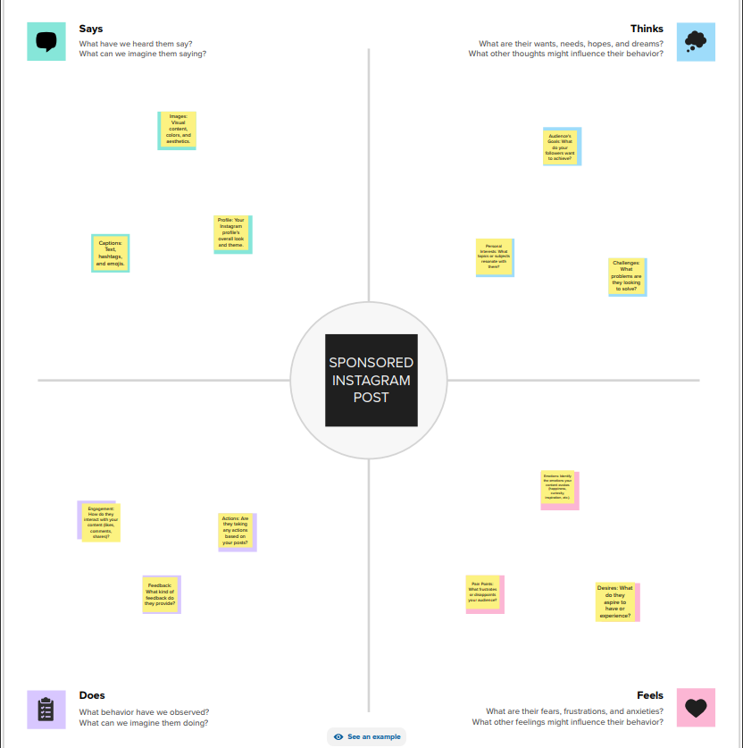

**2.Ideation & Brainstorming Map:**

Describe the process of generating ideas and possible solutions to the identified problem. Explain how different ideas were considered and evaluated.

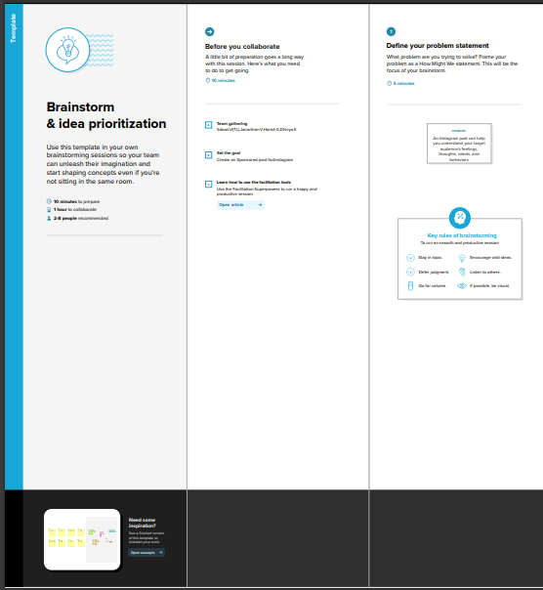

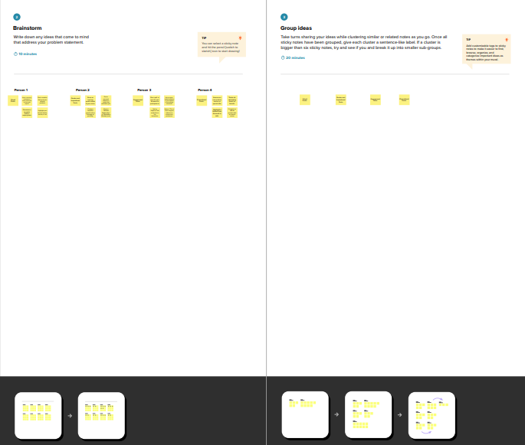

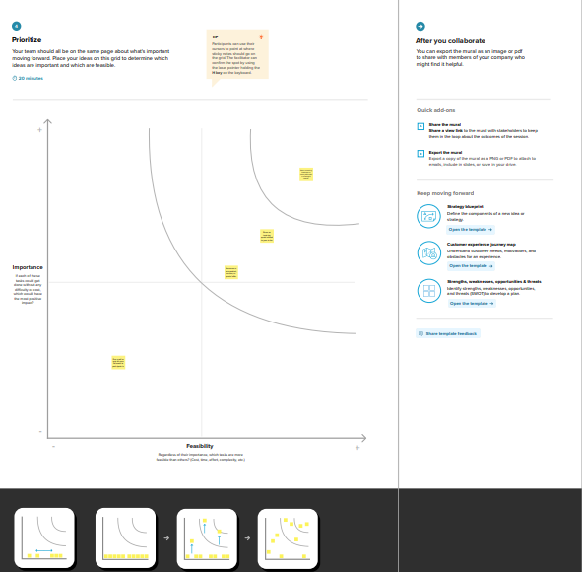

## 3.RESULT

## 

## 

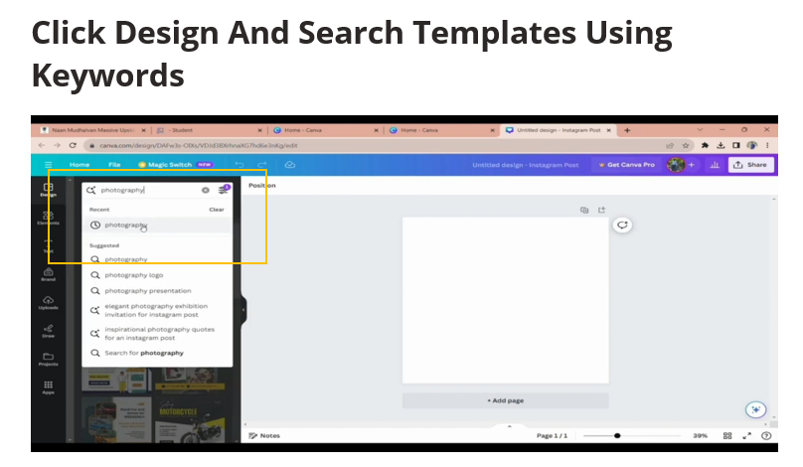

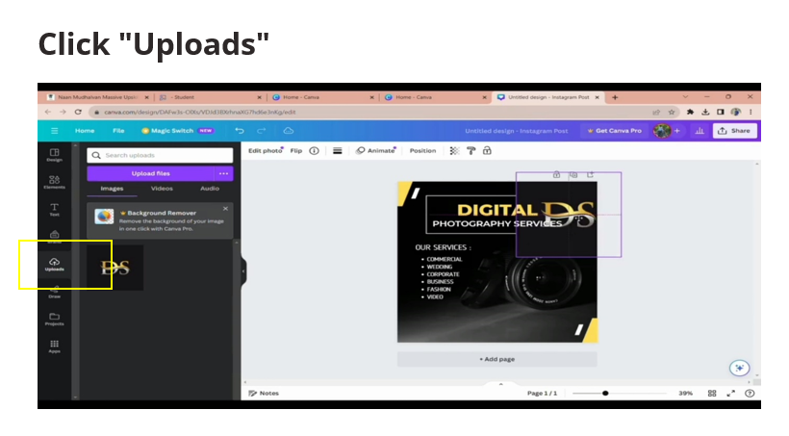

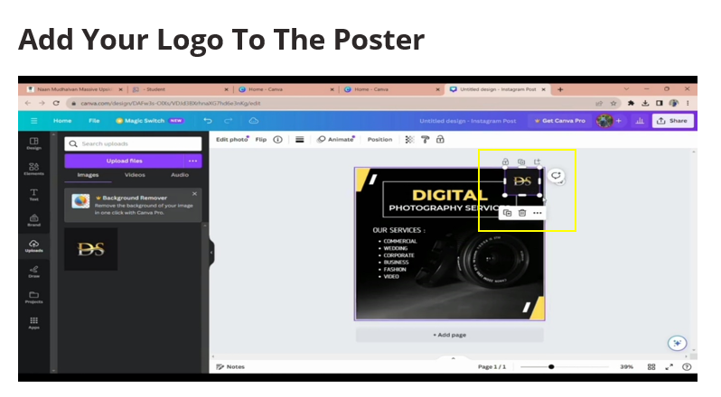

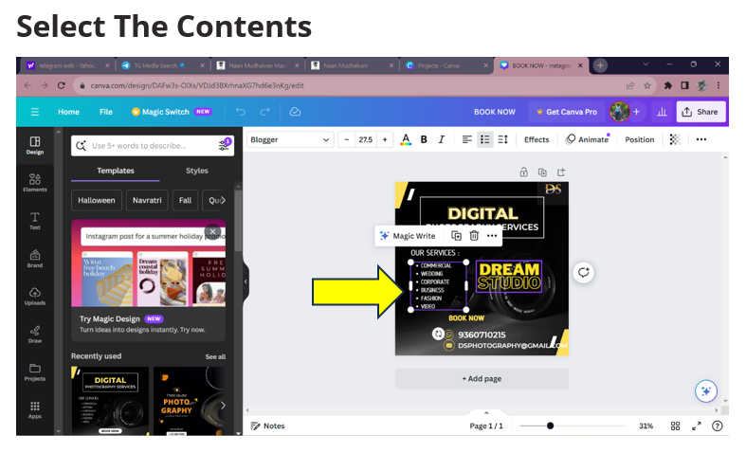

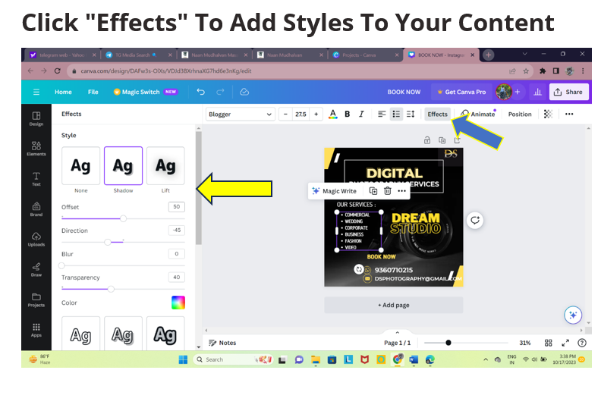

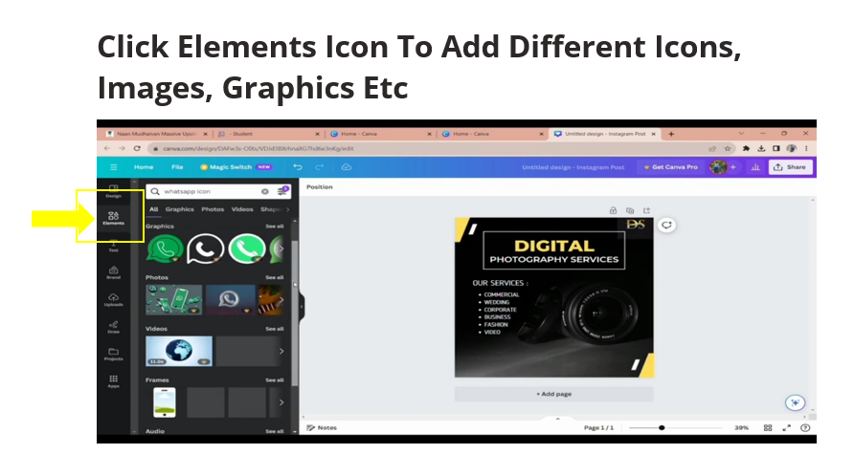

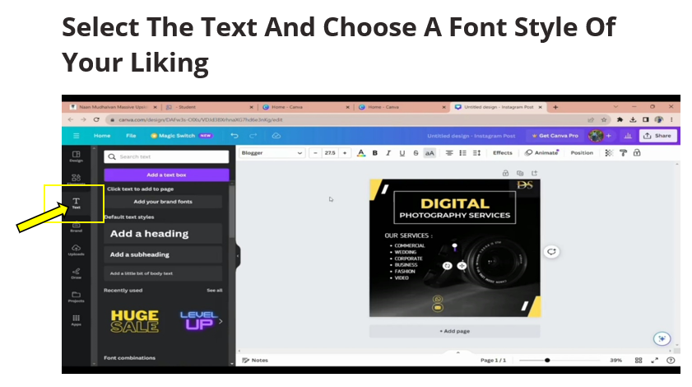

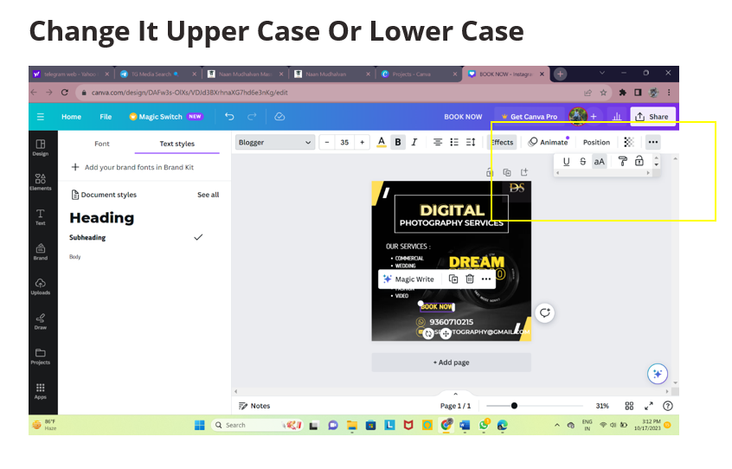

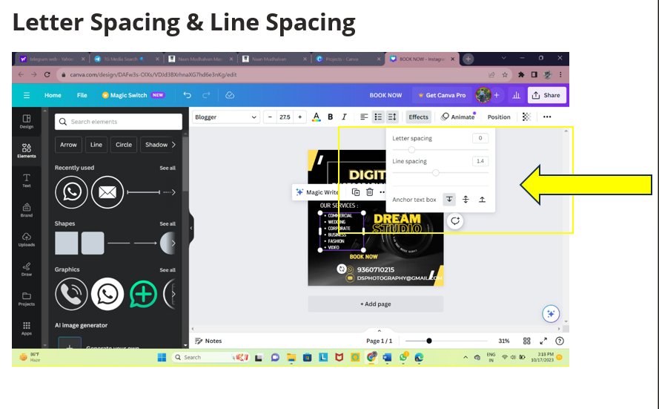

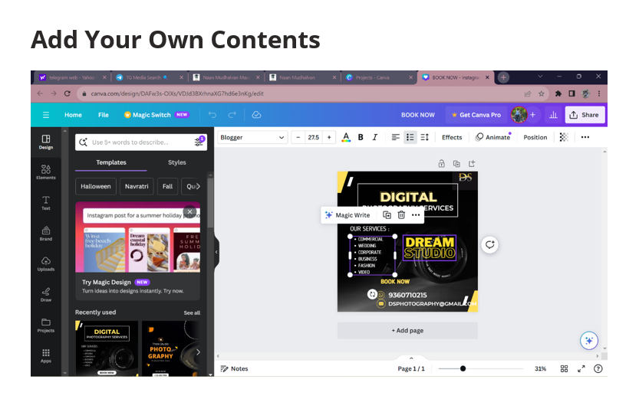

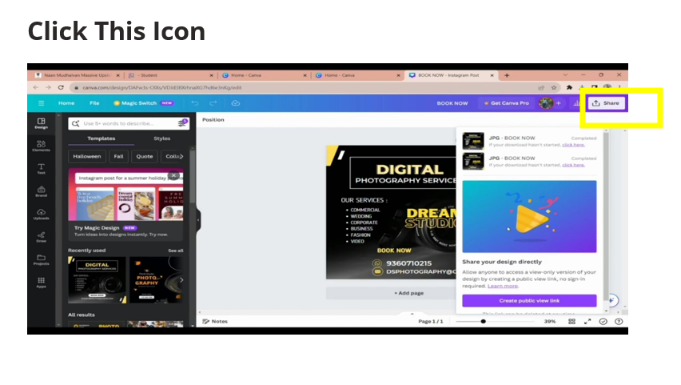

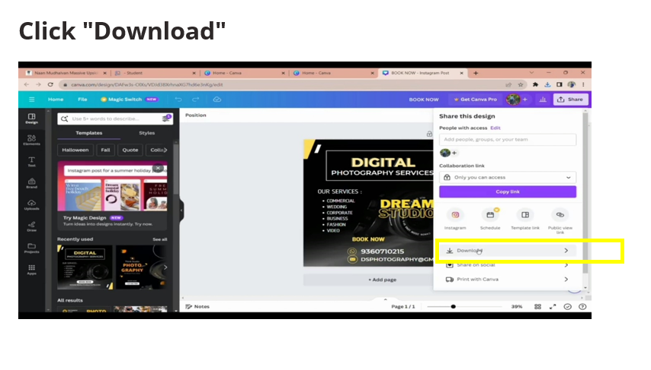

## 4.ADVANTAGES

## 

## Increased Visibility: Sponsored posts can reach a wider and more targeted audience

## than organic posts, helping brands gain exposure to potential customers they might

## not otherwise reach.

## Targeted Advertising: Brands can collaborate with influencers whose followers

## align with their target demographics, ensuring that their message reaches a

## relevant audience.

## Credibility and Trust: When influencers authentically endorse a product or service, it

## can build trust with their followers, who may be more likely to trust

## recommendations from someone they follow and admire.

## Engagement: Sponsored posts often generate higher levels of engagement, such as

## likes, comments, and shares, as they are crafted to be visually appealing and compelling.

## Content Quality: Influencers are skilled at creating high-quality, visually

## appealing content. Sponsored posts can provide brands with professional-grade

## images and videos that can be used for their own marketing efforts.

## DISADVANTAGES

## Cost: Collaborating with influencers and running sponsored campaigns can

## be expensive, especially when working with high-profile or celebrity

## influencers. Brands must allocate a budget for these partnerships.

## Authenticity Concerns: If not executed properly, sponsored posts can come across

## as inauthentic or insincere. Overly promotional content that doesn't align with

## the influencer's usual style or values can turn off their audience.

## Disclosure and Trust Issues: Maintaining transparency and clearly marking posts

## as "sponsored" is essential. Failing to do so can lead to trust issues and

## potential backlash from the audience or even regulatory authorities.

## Variable Results: The effectiveness of a sponsored post can be unpredictable.

## It depends on several factors, including the influencer's appeal, the product's fit

## with the audience, and the timing of the campaign.

## Limited Control: Brands may have limited control over the content and messaging in

## a sponsored post. While influencers should be given creative freedom, this lack

## of control can sometimes be a disadvantage if the content doesn't align with the

## brand's objectives.

## 5.APPLICATIONS

## Product Promotion: Brands often use sponsored Instagram posts to promote

## their products and highlight their features. Influencers can showcase how products

## are used in real-life situations, helping potential customers envision themselves using

## the product.

## Service Promotion: Companies that provide services, such as travel agencies,

## fitness trainers, or beauty salons, can use sponsored posts to showcase their services

## and generate interest.

## Event Promotion: Businesses can create sponsored posts to promote events, such

## as product launches, store openings, conferences, or trade shows. These posts

## can include event details and encourage attendance.

## Influencer Collaborations: Influencers can collaborate with other influencers or brands

## to cross-promote products or services to a broader audience. These collaborations can

## be beneficial for both parties involved.

## Sponsored Content Series: Brands can work with influencers to create a series

## of sponsored posts that revolve around a specific theme, such as travel, health

## and wellness, or fashion. This can create a consistent brand presence and message

## over time.

## Affiliate Marketing: Sponsored posts with affiliate links can help brands and

## influencers earn a commission for each sale generated through the post.

## Giveaways and Contests: Sponsored posts can be used to host giveaways and

## contests, encouraging engagement and growing the brand's following.

## Brand Awareness: Businesses can use sponsored posts to increase brand visibility

## and build awareness among a targeted audience. These posts may not directly promote

## a product or service but focus on the brand's values and identity.

## Education and Information: Influencers can use sponsored posts to educate

## their audience about specific topics, such as tutorials, how-to guides, or

## informational content.

## 6.CONCLUSION

## This conclusion combines a recap of the product's benefits, a clear CTA, gratitude,

## a signature, and relevant hashtags to create a well-rounded ending to the sponsored post.

## It encourages action, shows appreciation, and maintains a personal touch.

## For example:

## "Ready to take your workouts to the next level? The FitFlex resistance bands

## have been a game-changer for me! Don't miss out on this fitness essential. Check the link

## in my bio to grab yours today and start crushing your fitness goals! Thanks for all your

## support and commitment to a healthier you. Keep pushing! #FitFlex

## #FitnessGoals #SponsoredByFitFlex #Ad @YourUsername"

## 

## THANK YOU